Data analytics project 2

E commerce Data analysis:

Problem statement:

An e-commerce company wants to know their sales , products sold profit they gained and other meaningful insights

Objective:

The objective of the project is to analyze the dataset , clean it and extract business insights and create a simple dashboard .

End results:

- Business insights:

Sales by State:

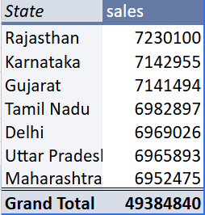

Sales by product category:

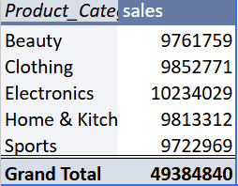

Top products By sales:

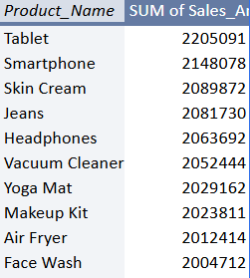

Most popular payment mode:

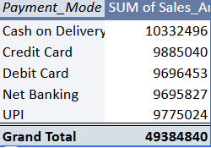
Profit by product category:

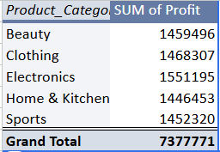

Monthly sales Trend:
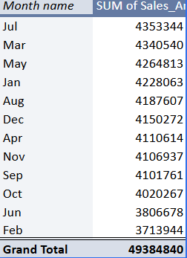

Dashboard:

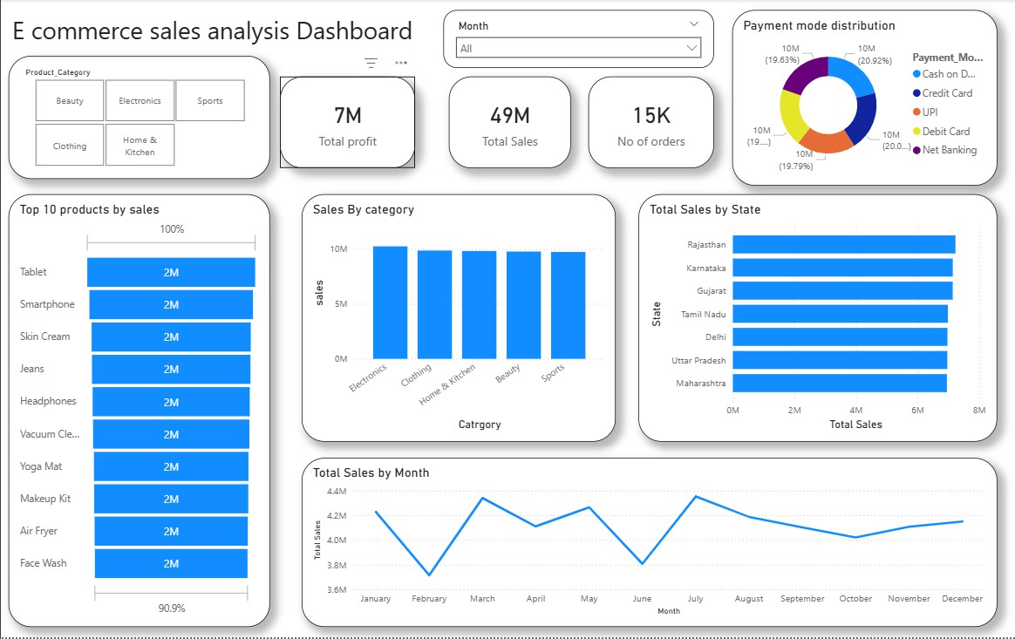

Questions Answered:

Which state generates the highest sales?

Rajasthan generates the high sales compared to other states.

Which product category is the most profitable?

Electronics are the most profitable as the large no of tablets , phones etc are sold.

Which products generate the highest revenue?

- Tablet
- Smartphone

- Skin cream
- Jeans
- Headphones
- Vacuum cleaner
- Yoga mat
- Makeup kit
- Air fryer
- Face wash

Which payment method is used the most?
Cash on delivery payment method is used the most as many people pay and get the product on the same day

What is the monthly sales trend?

At july , there were higher sales of 4 million with 1330 orders and on february , there were less sales of 561k with 1091 orders.

Conclusion:

With this , The whole dataset was analyzed with the extraction of business insights , creation of dashboard and answering the necessary questions which helps the organization to understand the sales and rely on them.

